A PROJECT REPORT
ON
“AI BASED CAPSICUM PLANT DISEASE DETECTION SYSTEM”
Report Submitted on partial fulfilment of the requirement of project work of
VI Semester
BACHELOR OF COMPUTER APPLICATIONS [BCA]
OF
DR. MANMOHAN SINGH BENGALURU CITY UNIVERSITY

Submitted By:
SHWETHA H A: U18IP23S0157.
Under the guidance of
Prof. HEMALATHA R MCA., M.Phil
Associate Professor

DEPARTMENT OF COMPUTER SCIENCE
SINDHI COLLEGE
Sindhi College, 33/2B, Kempapura, Hebbal, Bengaluru - 560 024
Phone Number: 080 2363 7543/44, Fax: 080 2363 7544
Email: info@sindhicollege.com, Website: www.sindhicollege.com
Permanently affiliated to Dr. Manmohan Singh Bengaluru City University & Approved by AICTE
Re-accredited by NAAC , ISO 9001:2015 Certified Institution, Recognised by UGC under 2(f) & 12(B)


Sindhi College
Sindhi College, 33/2B, Kempapura, Hebbal, Bengaluru - 560 024
Phone Number: 080 2363 7543/44, Fax: 080 2363 7544
Email: info@sindhicollege.com, Website: www.sindhicollege.com
Permanently affiliated to Dr. Manmohan Singh Bengaluru City University & Approved by AICTE
Re-accredited by NAAC , ISO 9001:2015 Certified Institution, Recognised by UGC under 2(f) & 12(B)

CERTIFICATE
This is to certify that the project entitled
“AI BASED CAPSICUM PLANT DISEASE DETECTION SYSTEM”

Submitted in the partial fulfilment of requirement for the award

Bachelor of Computer Applications [BCA]
Is the result of the bonafide work carried out by:
SHWETHA H A: U18IP23S0157.
During the academic year - 2025-2026

GUIDE HOD PRINCIPAL

Date:
Centre: SINDHI COLLEGE

Bachelor of Computer Applications [BCA]
Sindhi College, 33/2B, Kempapura, Hebbal, Bengaluru - 560 024
Phone Number: 080 2363 7543/44, Fax: 080 2363 7544
Email: info@sindhicollege.com, Website: www.sindhicollege.com
Permanently affiliated to Dr. Manmohan Singh Bengaluru City University & Approved by AICTE
Re-accredited by NAAC , ISO 9001:2015 Certified Institution, Recognised by UGC under 2(f) & 12(B)



Awarded to __________________________________________________________
This is to certify that the project entitled ___________________________________
____________________________________________________________________
Submitted in partial fulfilment of the requirement for the degree of Bachelor of
Computer Applications of Dr. Manmohan Singh Bengaluru City University.

GUIDE HOD PRINCIPAL
Signature of Examiners:

1. ______________________
2. ______________________

Bachelor of Computer Applications [BCA]
Sindhi College, 33/2B, Kempapura, Hebbal, Bengaluru - 560 024
Phone Number: 080 2363 7543/44, Fax: 080 2363 7544
Email: info@sindhicollege.com, Website: www.sindhicollege.com
Permanently affiliated to Dr. Manmohan Singh Bengaluru City University & Approved by AICTE
Re-accredited by NAAC , ISO 9001:2015 Certified Institution, Recognised by UGC under 2(f) & 12(B)

GUIDE CERTIFICATE

This is to certify that, SHWETHA H A [U18IP23S0157.] of Sindhi College, Hebbal has successfully completed the project entitled:

“AI BASED CAPSICUM PLANT DISEASE DETECTION SYSTEM”

In partial fulfilment of the requirement for the award of completion of project. This project is based on original and independent work and carried out under my guidance and supervision. This has not formed the basis for the reward of any degree or diploma of any other University or Institution.

PLACE: BENGALURU PROF.HEMALATHA R MCA., M.PHIL
DATE: (Project Guide)
DECLARATION

I, SHWETHA H A [U18IP23S0157.] student of VI Semester BCA, Sindhi College, Bengaluru do hereby declare that this is project report on:
“AI BASED CAPSICUM PLANT DISEASE DETECTION SYSTEM”

Has been prepared by me, as partial fulfilment of the requirement of the BCA program of Bengaluru City University (Batch of 2023-2026). My Guide for the training has been Prof. HEMALATHA R MCA., M.Phil, Associate Professor, Department of Computer Science, Sindhi College. I further declare that this project report has not been submitted earlier to any other university or institution for the award of any degree or diploma.

SUBMITTED BY:

NAME: SHWETHA H A [U18IP23S0157.]

PLACE: BENGALURU
DATE:

ACKNOWLEDGEMENT

It gives me immense pleasure to mention the names of the people who made my project report possible. I sincerely thank our College Management and Dr. ASHA N, M. Com, MBA, M.Phil. , Ph.D, PRINCIPAL, Sindhi College for giving me the opportunity to take up this research. I thank them for being a constant source of inspiration and encouragement.
I immensely thank Prof. E. K. RADHIKA , MS(IT), [Ph.D.], HOD Department of Computer Science, Prof. HEMALATHA R MCA., M.Phil, Associate Professor, Department of Computer Science ,Sindhi College for their guidance throughout the project. Without their continuous help, suggestions, & encouragement it would not have been possible for me to complete the project effectively. At the end I express my deep gratitude to my family, friends without whose cooperation this project would have not been possible.

PLACE: BENGALURU
DATE:

ABSTRACT

This project presents the development of an Artificial Intelligence (AI)-based Capsicum Plant Disease Detection System using deep learning techniques. Plant diseases are one of the major factors affecting agricultural productivity, and early detection is essential to prevent crop loss and ensure better yield. Traditional methods of disease identification rely on manual inspection, which can be time-consuming, less accurate, and requires expert knowledge.
The proposed system uses a Convolutional Neural Network (CNN) with the MobileNetV2 architecture to automatically classify capsicum leaf images as healthy or diseased. The dataset consists of labeled images of capsicum leaves, which are preprocessed through resizing and normalization before being fed into the model. The system also includes data handling techniques such as dataset extraction, organization, and splitting into training and validation sets to improve model performance.
The model is trained using transfer learning, where the pre-trained MobileNetV2 model is fine-tuned for the specif ic task of plant disease detection. During training, the system learns important visual features such as color variations, texture patterns, and spots on leaves that indicate disease. The performance of the model is evaluated using accuracy and loss metrics, and the results are visualized through graphs.
The developed system is capable of predicting the condition of a leaf image and classifying it as Healthy or Diseased (Bacterial Leaf Spot). This solution provides a fast, cost-effective, and reliable method for plant disease detection. The project demonstrates the practical application of AI in agriculture and highlights its potential to support farmers in making timely decisions.
In the future, this system can be enhanced by including more disease categories, improving model accuracy with larger datasets, and deploying it as a mobile or web-based application for real-time usage.

CONTENTS

Page No.
1. Introduction

2. System and Software requirements
3. Diagrams – ER Diagram & Data Flow Diagram

4. Software Implementation
5. Coding
6. Snapshots
7. Conclusion
8. Future Enhancements
9. Bibliography

1.INTRODUCTION

Agriculture plays a vital role in the economy and food production, and maintaining the health of crops is essential for ensuring high yield and quality. However, plant diseases remain one of the major challenges faced by farmers, as they can spread rapidly and cause significant damage if not detected at an early stage. Capsicum (pepper) plants are particularly vulnerable to diseases such as bacterial leaf spot, which affects the leaves and reduces the productivity of the crop.
Traditionally, plant disease detection is carried out through manual inspection by experts or farmers. This approach is often time-consuming, requires domain knowledge, and may lead to inaccurate results due to human error or lack of expertise. With the advancement of technology, Artificial Intelligence (AI) has emerged as a powerful tool to automate and improve the accuracy of such tasks.
This project focuses on the development of an AI-based Capsicum Plant Disease Detection System using deep learning techniques. The main objective of the system is to automatically identify whether a capsicum leaf is healthy or affected by disease by analyzing its image. This is achieved using a Convolutional Neural Network (CNN), which is widely used for image classification tasks due to its ability to learn complex visual patterns.
By applying transfer learning, the model is adapted to classify capsicum leaf images into different categories such as healthy and diseased.
The system involves several stages, including dataset collection, preprocessing, model training, and prediction. The input images are resized and normalized before being fed into the model. During training, the model learns to recognize features such as color variations, spots, and texture differences that indicate the presence of disease. After training, the system can predict the condition of new leaf images and provide results quickly and accurately.
This project demonstrates the practical application of AI and computer vision in agriculture. It helps in reducing manual effort, improving detection accuracy, and enabling early diagnosis of plant diseases. Such systems can assist farmers in taking timely actions, thereby improving crop health and productivity.
In the future, this system can be further enhanced by including more types of plant diseases, increasing dataset size for better accuracy, and deploying the model as a mobile or web-based application for real-time usage in agricultural fields.

2.SYSTEM AND SOFTWARE REQUIREMENT

The development and implementation of the AI-based Capsicum Plant Disease Detection System require a suitable computing environment capable of handling image processing, model training, and prediction tasks. Since the project involves deep learning and image classification, it requires sufficient hardware resources and a properly configured software environment.
This section describes the hardware and software requirements necessary for the successful execution of the project. These requirements ensure smooth dataset handling, efficient model training, and accurate prediction results.

2.1 Hardware Requirements
The hardware requirements define the minimum and recommended physical resources needed to execute the project efficiently. The performance of the deep learning model depends on the available computational power.
1. Processor (CPU)
A processor is required to execute data preprocessing, model training, and prediction tasks.
- Minimum Requirement: Intel Core i3 or equivalent
- Recommended Requirement: Intel Core i5 / i7 or AMD Ryzen equivalent
A multi-core processor improves performance during training and data loading.
2. Random Access Memory (RAM)
RAM is used to store image data, model parameters, and intermediate computations.
- Minimum Requirement: 4 GB RAM
- Recommended Requirement: 8 GB or higher
Higher RAM allows faster processing of large image datasets and smooth execution.
3. Storage Requirements
Storage is required to store dataset files, trained models, and output results.
- Minimum Requirement: 5 GB free disk space
- Recommended Requirement: 10 GB or more
SSD storage is preferred for faster read/write operations.
4. Graphics Processing Unit (GPU)
A GPU is not mandatory but significantly improves training speed for deep learning models.
- Optional Requirement: NVIDIA GPU (CUDA supported)
- Recommended: Cloud GPU (Google Colab – Tesla T4)
Using a GPU reduces training time and improves model performance.
5. Display and Input Devices
These are required to visualize outputs and interact with the system.
- Minimum Resolution: 1366 × 768 pixels
- Input Devices: Keyboard and mouse
These help in monitoring training progress and viewing prediction results.
2.2 Software Requirements
The software requirements include the operating system, programming language, development tools, and libraries used in the project.
1. Operating System
The project can run on multiple operating systems that support Python and machine learning libraries.
Supported Operating Systems:
- Windows 10 / 11
- Linux (Ubuntu preferred)
- macOS
2. Programming Language
The project is implemented using Python, which is widely used in Artificial Intelligence and Machine Learning.
- Version Used: Python 3.8 or higher
Advantages of Python:
- Simple and readable syntax
- Large number of ML libraries
- Strong community support
3. Development Environment
Google Colab
Google Colab is a cloud-based platform used to develop and train the model.
Advantages:
- Free GPU support
- No installation required
- Easy dataset upload (Google Drive)
- Accessible from anywhere
2.3 Libraries and Frameworks Used
The project uses several Python libraries for image processing, model building, and visualization.
1. TensorFlow / Keras
Used for building and training the deep learning model.
Functions:
- Model creation
- Training and validation
- Transfer learning (MobileNetV2)
- Prediction
2. MobileNetV2
A pre-trained deep learning model used for image classification.
Features:
- Lightweight and fast
- High accuracy
- Suitable for real-time applications
3. ImageDataGenerator
Used for loading and preprocessing image data.
Functions:
- Image rescaling
- Data augmentation
- Training/validation split
4. NumPy
Used for numerical operations.
Uses:
- Array manipulation
- Image data processing
- Mathematical operations
5. Matplotlib
Used for visualization.
Uses:
- Plotting accuracy graphs
- Plotting loss graphs
- Displaying prediction results
6. OS and Zipfile
Used for file handling.
Functions:
- Dataset extraction
- Folder management
- File organization
2.4 Development Setup
The project is executed mainly using Google Colab, where the dataset is uploaded in ZIP format and extracted using Python. The dataset is automatically organized into class folders, and preprocessing is performed using ImageDataGenerator.
The model is built using MobileNetV2 with transfer learning and trained on the processed dataset. Training performance is monitored using accuracy and loss graphs. Finally, the trained model is used to predict whether a capsicum leaf is healthy or diseased.

3. DIAGRAMS- ER DIAGRAMS & DATA FLOW DIAGRAM
Diagrams play an important role in understanding the structure and working of a system. In this project, the Entity Relationship (ER) Diagram and Data Flow Diagram (DFD) are used to represent the system architecture, data flow, and interaction between different components involved in the AI-based plant disease detection process.
3.1 Entity Relationship (ER) Diagram
The Entity Relationship (ER) Diagram represents the logical structure of the system by identifying the main entities, their attributes, and the relationships between them. Although this project does not use a traditional database system, the ER diagram helps in understanding how different components such as images, model, and predictions interact with each other.
Entities Identified
1. Dataset
Represents the collection of capsicum leaf images used for training and testing the model.
Attributes:
- Dataset_ ID
- Image_ Path
- Image_ Label (Healthy / Diseased)
- Image_ Format (JPG/PNG)
2. Image
Represents individual leaf images that are processed by the system.
Attributes:
- Image_ ID
- Image_ Data
- Image_ Size
- Preprocessed_ Status
3. Preprocessing
Represents the image preprocessing stage before feeding into the model.
Attributes:
- Process_ ID
- Resize_ Dimension (224×224)
- Normalization_ Status
- Augmentation_ Status
4. Model (CNN – MobileNetV2)
Represents the deep learning model used for classification.
Attributes:
- Model_ ID
- Model_ Type (MobileNetV2)
- Accuracy
- Loss
- Epochs
5. Prediction
Represents the output generated by the model.
Attributes:
- Prediction_ ID
- Predicted_ Class (Healthy / Diseased)
- Confidence_ Score
6. Recommendation
Represents the suggestions and guidance provided to the user based on the prediction result.
Attributes:
- Recommendation_ ID
- Treatment_ Suggestions
- Fertilizer_ Suggestions
- Precautions
- Recommendation _ Type
7. User
Represents the user interacting with the system.
Attributes:
- User_ ID
- Input_ Image
- Prediction_ Result
Relationships
- The Dataset contains multiple Images
- Each Image undergoes Preprocessing
- The Preprocessed Images are given as input to the Model
- The Model generates Predictions
- The User provides input images and receives prediction results

ER DIAGRAM
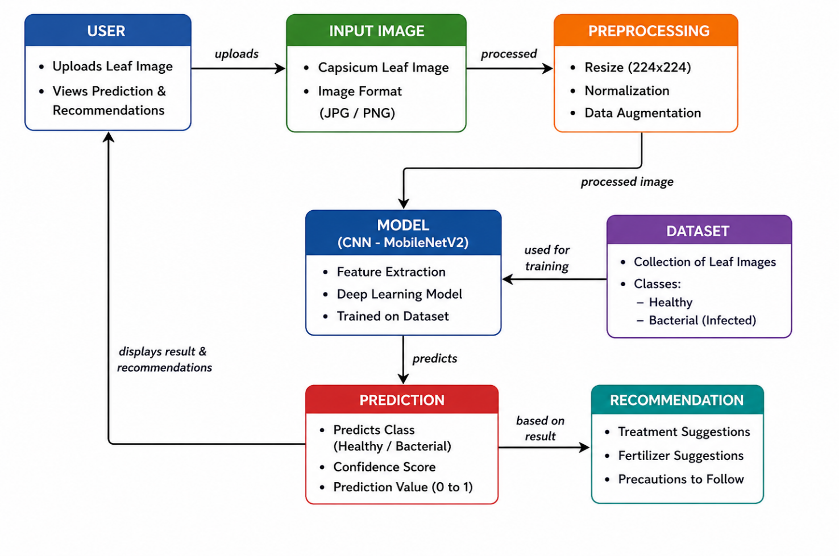
The ER diagram shows that the Model (CNN – MobileNetV2) is the central component of the system. It interacts with multiple entities such as the dataset, preprocessing module, and prediction module to perform accurate classification of capsicum leaf images. The dataset provides labeled images that are used during the model training phase to train and improve the model’s performance. The preprocessing module prepares the input image by resizing and normalizing it before passing it to the model.
This relationship structure helps in understanding how different components work together in the system to achieve accurate plant disease detection and provide meaningful guidance to the user.

3.2 DATA FLOW DIAGRAM
The Data Flow Diagram (DFD) represents how data flows through the AI-Based Capsicum Plant Disease Detection System. The process starts when the user uploads a leaf image, which is then sent to the preprocessing module for resizing and normalization.
The processed image is given to the trained model (MobileNetV2), which analyzes the image and generates a prediction (Healthy or Diseased). Based on the result, the system provides recommendations such as treatments and precautions.
Finally, the output is displayed to the user. The model is trained separately using a dataset of labeled images, which helps improve prediction accuracy.

LEVEL 0
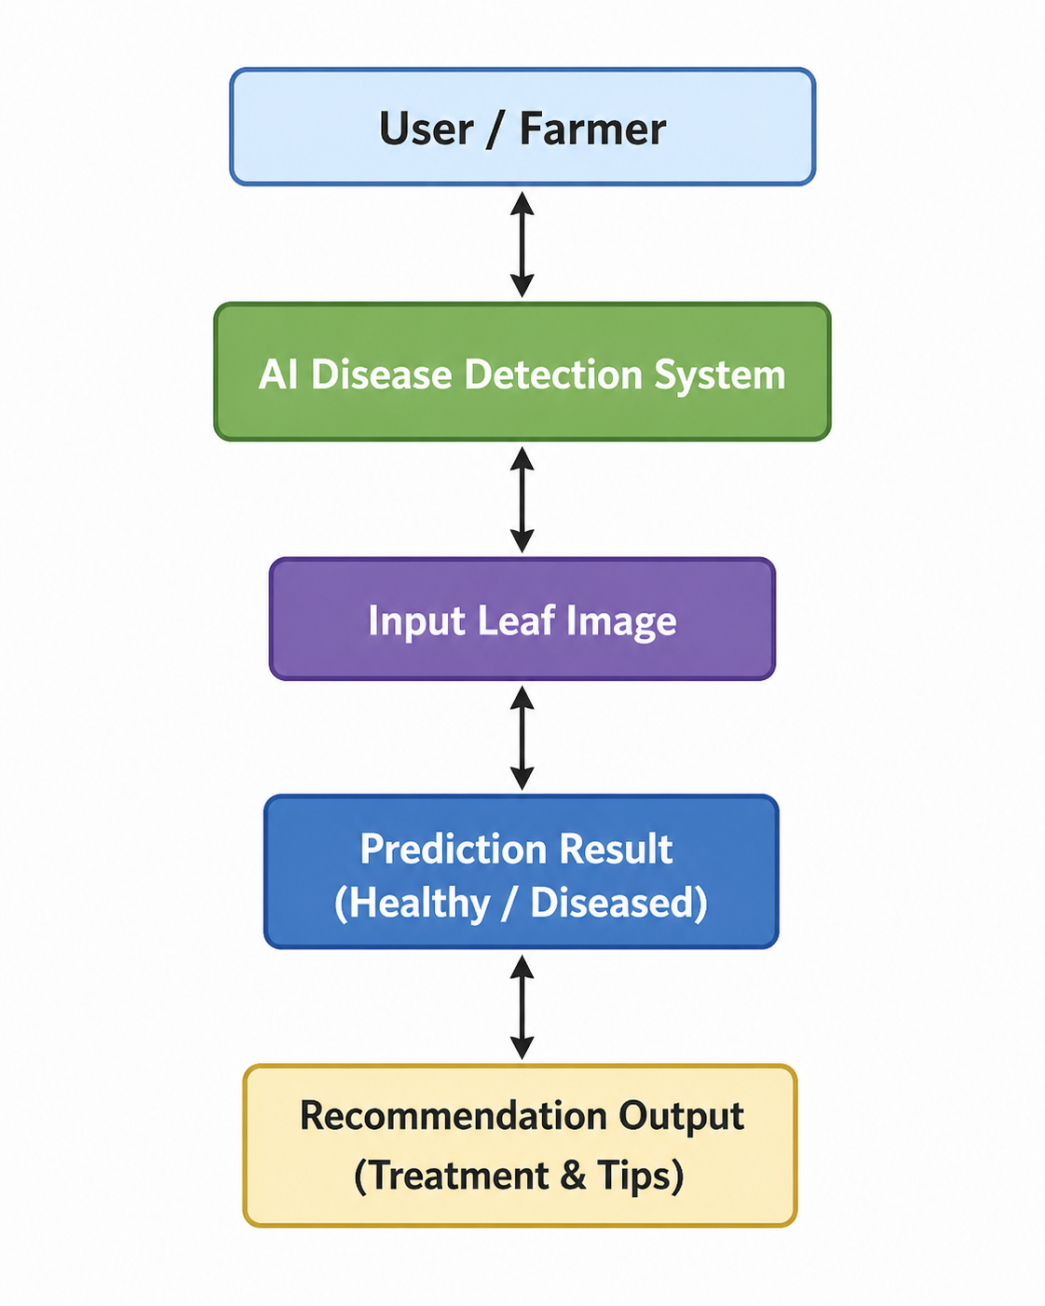
The User/Farmer provides a leaf image as input to the system
The AI Disease Detection System processes the image using a trained deep learning model (MobileNetV2)
The system produces output such as prediction results (Healthy/Diseased) and recommendations (treatment and precautions)

LEVEL 1
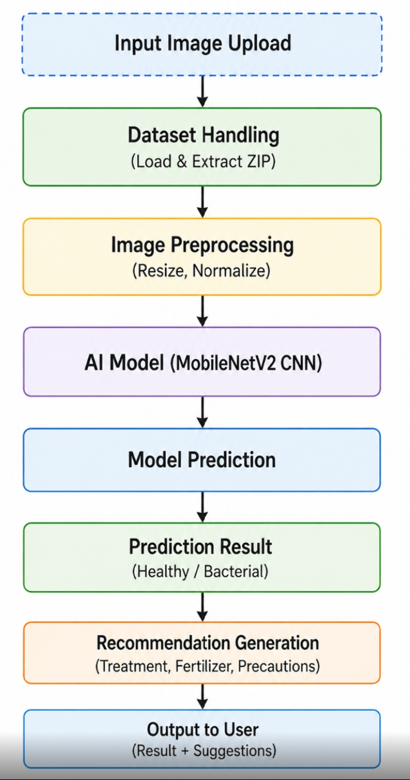

1. Input Image Upload
The user uploads a capsicum leaf image into the system. This image acts as the primary input for detecting whether the leaf is healthy or diseased
2. Dataset Handling
The system loads and extracts the dataset of labeled leaf images. This dataset is used for training the model and improving its ability to recognize disease patterns.
3. Image Preprocessing
The input image is resized to a fixed dimension (224×224) and normalized. This step ensures that the image is in the correct format for the deep learning model.
4. AI Model (MobileNetV2)
A pre-trained deep learning model is used to analyze the image. It learns important features such as color, texture, and spots to differentiate between healthy and diseased leaves
5. Model Prediction
The processed image is passed through the model, which generates a prediction value. Based on this value, the system determines whether the leaf is healthy or infected.
6. Prediction Result
The system classifies the leaf as Healthy or Diseased (Bacterial Infection) along with a confidence score indicating the accuracy of the prediction.
7. Recommendation Generation
Based on the prediction, the system provides useful suggestions such as treatments, fertilizer recommendations, and precautions to control or prevent disease.
8. Output to user
The final result, including prediction and recommendations, is displayed to the user along with the leaf image for easy understanding.

4. SOFTWARE IMPLIMENTATION
The software implementation of the AI-based Capsicum Plant Disease Detection System involves the design, development, and execution of a deep learning model that can automatically classify leaf images as healthy or diseased. This section explains the complete implementation process, including dataset handling, image preprocessing, model development, training, evaluation, and prediction.
The project is implemented using Python and various machine learning libraries, with a focus on a Convolutional Neural Network (CNN) using the MobileNetV2 architecture for image classification. MobileNetV2 is a pre-trained model that enables efficient and accurate feature extraction, making it suitable for real-time applications.
The implementation begins with dataset preparation, where the image dataset is uploaded in ZIP format, extracted, and organized into different class folders such as Healthy and Diseased. The dataset is then loaded using image data generators, which also handle tasks such as rescaling and splitting the data into training and validation sets.
Next, image preprocessing is performed to standardize the input images. All images are resized to a fixed dimension (224×224 pixels) and normalized to improve model performance. Data augmentation techniques can also be applied to increase dataset diversity and reduce overfitting.
The model development phase involves loading the MobileNetV2 base model with pre-trained weights and adding custom layers such as global pooling, dense layers, and dropout for classification. Transfer learning is used to adapt the model for the specific task of capsicum disease detection.
During the training phase, the model learns from the dataset by adjusting its weights to minimize classification errors. The training process is monitored using metrics such as accuracy and loss, and validation data is used to evaluate the model’s performance.
After training, the model is used for prediction, where new leaf images are provided as input. The system processes the image and predicts whether it is healthy or diseased. Based on the prediction, the system also generates recommendations, including treatment suggestions and preventive measures.
Finally, visualization tools such as graphs are used to display training accuracy and loss, helping to analyze the model’s learning performance.

4.1 Overview of Implementation
he implementation of the AI-based Capsicum Plant Disease Detection System follows a structured approach consisting of the following stages:
- Installation of Required Libraries
Required libraries such as TensorFlow, Keras, NumPy, and Matplotlib are installed for building and training the model.
- Dataset Upload and Extraction
The dataset is uploaded in ZIP format, extracted, and organized into class folders like Healthy and Diseased.
- Image Preprocessing
Images are resized and normalized to make them suitable for the deep learning model.
- Model Development (MobileNetV2)
A pre-trained MobileNetV2 model is used and customized for image classification.
- Model Training
The model is trained using the dataset to learn patterns and features of healthy and diseased leaves.
- Model Evaluation
The performance of the model is evaluated using accuracy and loss metrics.
- Prediction and Recommendation
The trained model is used to predict new images and provide suggestions such as treatments and precautions.
- Visualization of Results
Graphs are plotted to show training accuracy and loss for better understanding of model performance.
4.2 Environment Setup and Configuration
The first step in the implementation process is setting up the dataset and development environment. The project uses image data of capsicum leaves and deep learning libraries to build the detection system.
- Image Size: 224 × 224 pixels
- Batch Size: 32 images per batch
- Epochs: 10 (number of training cycles)
- Classes: Healthy and Diseased (Bacterial)
The dataset is uploaded in ZIP format, extracted, and organized into class folders. This setup ensures that the model receives properly structured data for training.
The input (observation) to the system is a leaf image, and the output (action) is the classification result (Healthy or Diseased) along with recommendations.
This configuration helps the model learn meaningful features such as color, texture, and disease patterns from the images.
4.3 Initial Model Performance (Baseline Model)
Before training the deep learning model, the dataset and system are tested to ensure that the images are loaded and processed correctly. This step acts as an initial validation phase before the actual model training process begins.
The purpose of this step is to:
- Verify whether the dataset is properly extracted and organized
- Check if the images are correctly loaded into the system
- Ensure preprocessing steps such as resizing and normalization work properly
- Confirm that the class labels (Healthy and Diseased) are assigned correctly
- Prepare a reliable foundation for model training
During this stage, sample images are processed and passed through the system to test the workflow. The preprocessing module converts images into the required format so they can be used by the MobileNetV2 model.
Before training, the system may show:
- Low prediction accuracy
- Incorrect classifications
- Unoptimized results
This occurs because the model has not yet learned the important features and patterns from the dataset.
The initial testing phase helps in identifying errors related to:
- Dataset structure
- Image loading
- Path configuration
- Class imbalance
- Preprocessing issues
By validating the dataset and preprocessing pipeline before training, the system ensures smoother execution and better performance during the actual training phase. This step also provides a baseline understanding of the system before improvements are achieved through model training.
4.4 MobileNetV2 Model Development
In this project, a deep learning model is developed using MobileNetV2, which is a pre-trained Convolutional Neural Network (CNN). It is widely used for image classification tasks due to its high accuracy and lightweight structure.
MobileNetV2 is used as the base model with pre-trained weights from ImageNet. The top layers of the model are removed, and custom layers are added to adapt it for capsicum disease detection.
The model consists of the following layers:
- Base Model (MobileNetV2) – Extracts important features from images
- Global Average Pooling Layer – Reduces feature dimensions
- Dense Layer (128 neurons) – Learns complex patterns
- Dropout Layer (0.5) – Prevents overfitting
- Output Layer (Sigmoid) – Classifies image as Healthy or Diseased
The base model is frozen (non-trainable) to retain pre-trained knowledge, while the added layers are trained on the capsicum dataset.
The model is compiled using:
- Optimizer: Adam
- Loss Function: Binary Crossentropy
- Metric: Accuracy
This model development approach uses transfer learning, which improves performance even with a smaller dataset and reduces training time.
4.5 Model Hyperparameters and Configuration
The performance of the MobileNetV2 model depends on several hyperparameters, which are carefully selected to improve accuracy and ensure stable training. These parameters control how the model learns from the dataset during the training process.
Hyperparameters Used
- Image Size (224 × 224)
All input images are resized to 224 × 224 pixels for uniform processing.
- Batch Size (32)
Defines the number of images processed in one training batch. A batch size of 32 helps balance training speed and memory usage.
- Epochs (10)
Represents the number of times the complete dataset is passed through the model during training. More epochs help the model learn better features.
- Learning Rate (Adam Optimizer)
Controls how quickly the model updates its weights during training. The Adam optimizer provides faster and efficient learning.
- Loss Function (Binary Crossentropy)
Measures the difference between predicted and actual outputs for binary classification (Healthy or Diseased).
- Activation Function (ReLU & Sigmoid)
ReLU is used in hidden layers for faster learning, while Sigmoid is used in the output layer for binary classification.
- Dropout Rate (0.5)
Prevents overfitting by randomly disabling some neurons during training.
- Validation Split (0.2)
Splits 20% of the dataset for validation to evaluate model performance during training.
These hyperparameters are configured to improve prediction accuracy, reduce overfitting, and achieve better performance in capsicum plant disease detection.
4.6 Training Process
After developing the MobileNetV2 model, the next step is training the model using the capsicum leaf image dataset. Model training is an important phase where the system learns to identify patterns and features from healthy and diseased leaf images.
The dataset is divided into:
- Training Data (80%) – Used to train the model
- Validation Data (20%) – Used to test model performance during training
The images are loaded using the ImageDataGenerator function, which also performs preprocessing such as rescaling and validation splitting.
During training:
- The model processes images in batches
- Features such as color changes, spots, and texture patterns are learned
- The model continuously updates its weights to reduce prediction errors
The training is performed using:
- Batch Size: 32
- Epochs: 10
- Optimizer: Adam
- Loss Function: Binary Crossentropy
For each epoch, the system calculates:
- Training Accuracy
- Validation Accuracy
- Training Loss
- Validation Loss
Accuracy shows how correctly the model predicts images, while loss indicates the error during prediction. As training progresses:
- Accuracy increases
- Loss decreases
This indicates that the model is learning effectively from the dataset.
The trained model is then capable of classifying capsicum leaves as:
- Healthy
- Bacterial Diseased
The training results are visualized using graphs for better analysis and understanding of model performance.
4.7 Training Monitoring and Visualization
Training monitoring and visualization are important stages in the development of the AI-based Capsicum Plant Disease Detection System. After the model is created and trained using the dataset, its performance must be continuously monitored to understand how effectively it is learning to classify healthy and diseased leaf images.
During the training process, the model learns patterns, textures, and color differences from the dataset by adjusting its internal parameters. The system evaluates the model performance after every training cycle, known as an epoch. Monitoring these results helps in analyzing whether the model is improving or if any changes are required to enhance accuracy.
The project mainly focuses on two important performance metrics:
1. Accuracy
Accuracy represents how correctly the model predicts the class of the leaf images.
- Training Accuracy:
Shows the percentage of correctly classified images during training.
- Validation Accuracy:
Shows how well the model performs on unseen validation images.
Higher accuracy indicates better prediction capability of the model.
2. Loss
Loss measures the error in the model predictions.
- Training Loss:
Indicates the error generated during training.
- Validation Loss:
Indicates the prediction error on validation data.
Lower loss values indicate better model performance and learning efficiency.
During each epoch:
- The model processes training images
- Compares predictions with actual labels
- Calculates accuracy and loss
- Updates weights to improve performance
The validation dataset is used to test the model after every epoch and ensure that it performs well on new images.
Visualization Using Graphs
To better understand the learning progress, the project uses Matplotlib to generate graphs for training and validation performance.
Accuracy Graph
The accuracy graph shows:
- Improvement in training accuracy
- Improvement in validation accuracy
- Overall learning progress of the model
If both accuracy curves increase steadily, it indicates successful learning.
Loss Graph
The loss graph shows:
- Reduction in training loss
- Reduction in validation loss
- Stability of the model during training
A decreasing loss graph indicates that the model is reducing prediction errors over time.

Importance of Visualization
Visualization helps in:
- Understanding model behavior
- Measuring prediction performance
- Detecting overfitting and underfitting
- Comparing training and validation results
- Improving overall model efficiency
It also helps developers identify whether:
- The model requires more training
- Dataset quality needs improvement
- Additional preprocessing is required
Overfitting and Underfitting Analysis
Overfitting
Occurs when:
- Training accuracy becomes very high
- Validation accuracy remains low
This means the model memorizes training data instead of learning general patterns.
Solution Used:
- Dropout layer
- Validation split
- Transfer learning
Underfitting
Occurs when:
- Both training and validation accuracy remain low
This indicates that the model has not learned enough features from the dataset.
Possible Solutions:
- Increase training epochs
- Improve dataset quality
- Use more training images
At the end of training, the graphs provide a clear visualization of how effectively the MobileNetV2 model learns to classify capsicum leaf diseases. Proper monitoring and visualization ensure that the model achieves reliable accuracy and stable performance before being used for prediction.
4.8 Model Evaluation
Model evaluation is the process of testing the performance of the trained deep learning model. In this project, the MobileNetV2 model is evaluated to determine how accurately it can classify capsicum leaf images as healthy or diseased.
The evaluation process helps in measuring:
- Accuracy of predictions
- Error rate of the model
- Reliability and efficiency of the system
After training, the model is tested using validation images that were not used during training. This helps in checking whether the model can correctly identify new and unseen leaf images.
Two important metrics are used during evaluation:
1. Accuracy
Accuracy measures how correctly the model classifies the images. Higher accuracy indicates better model performance and reliable disease detection.
2. Loss
Loss measures the error in prediction. Lower loss values indicate that the model is learning effectively and making fewer mistakes.
The model performance is monitored after every training epoch using training and validation datasets. The obtained results are visualized using accuracy and loss graphs, which help in understanding the learning progress of the model.
The trained model is also evaluated by testing individual leaf images through the prediction function. The system predicts whether the leaf is healthy or diseased based on the prediction value generated by the model.
Model evaluation is important because it helps in:
- Checking prediction quality
- Improving model performance
- Detecting overfitting or underfitting
- Ensuring reliable disease detection
The evaluation results confirm that the AI-based Capsicum Plant Disease Detection System can accurately classify leaf images and provide dependable prediction results for agricultural applications.
4.9 Prediction & Recommendation
Prediction and recommendation are the final stages of the AI-based Capsicum Plant Disease Detection System. In this stage, the trained MobileNetV2 model is used to analyze new capsicum leaf images and identify whether the leaf is healthy or affected by disease.
The prediction process begins when the user provides a leaf image as input to the system. The image is first resized and normalized to match the format required by the model. After preprocessing, the image is passed to the trained deep learning model for classification.
The model generates a prediction value based on the learned patterns and features from the training dataset. Using this prediction value, the system classifies the leaf into one of the following categories:
- Healthy Leaf
- Diseased Leaf (Bacterial Infection)
If the prediction value is greater than the defined threshold, the leaf is classified as healthy. Otherwise, it is classified as diseased.
After generating the prediction result, the system also provides recommendations to help users take appropriate actions.
For Healthy Leaves
The system provides maintenance suggestions such as:
- Proper watering
- Using organic fertilizers
- Ensuring adequate sunlight
- Regular monitoring of leaves
For Diseased Leaves
The system provides:
- Treatment suggestions
- Fertilizer recommendations
- Preventive measures and precautions
Suggested treatments include:
- Copper-based fungicides
- Neem oil spray
- Balanced fertilizers
Precautions include:
- Removing infected leaves
- Avoiding excess watering
- Maintaining proper plant spacing
- Disinfecting gardening tools
The system also displays the uploaded leaf image along with the prediction result, making the output more user-friendly and easier to understand.
This module improves the practical usefulness of the project by not only detecting diseases but also guiding users with proper agricultural recommendations.
4.10 Visualization of Results
Visualization of results is an important part of the AI-based Capsicum Plant Disease Detection System. It helps in understanding the performance and learning progress of the deep learning model during training and evaluation.
In this project, graphs are generated to display important metrics such as:
- Training Accuracy
- Validation Accuracy
- Training Loss
- Validation Loss
These graphs provide a clear visual representation of how well the model is learning from the dataset.
Accuracy Visualization
The accuracy graph shows the improvement in the model’s prediction performance over different training epochs. Increasing accuracy values indicate that the model is learning to classify healthy and diseased leaf images correctly.
Loss Visualization
The loss graph shows the reduction in prediction errors during training. Decreasing loss values indicate better learning efficiency and improved model performance.
The project uses the Matplotlib library to generate these visualizations. The graphs help in:
- Monitoring model performance
- Comparing training and validation results
- Detecting overfitting and underfitting
- Improving model efficiency
The system also displays the uploaded leaf image along with the prediction result (Healthy or Diseased), making the output easy to understand for users.
Visualization plays an important role in analyzing the effectiveness of the model and ensuring reliable disease detection performance.
4.11 Simulation Output
The simulation output represents the final results generated by the AI-based Capsicum Plant Disease Detection System after processing and analyzing the input leaf image. It shows how the trained model performs in real-time prediction and classification tasks.
In this project, the user uploads a capsicum leaf image, and the system processes the image using the trained MobileNetV2 model. After analysis, the system produces the following outputs:
- Predicted leaf condition (Healthy or Diseased)
- Prediction confidence value
- Display of the input leaf image
- Treatment recommendations
- Fertilizer suggestions
- Preventive precautions
The output is displayed in a user-friendly format so that users can easily understand the condition of the plant.
Healthy Leaf Output
If the leaf is healthy, the system displays:
- Healthy status
- No disease detected
- Basic plant care recommendations
Diseased Leaf Output
If the leaf is infected, the system displays:
- Disease detection result
- Suggested treatments
- Recommended fertilizers
- Precautionary measures to prevent disease spread
The project also generates visual outputs such as:
- Accuracy graphs
- Loss graphs
- Predicted image display with classification title
These outputs help in analyzing the effectiveness and reliability of the system. The simulation output demonstrates how AI can be used for real-time plant disease detection and agricultural support applications.
4.12 Model Saving and Loading
Model saving and loading are important steps in the AI-based Capsicum Plant Disease Detection System. After training the MobileNetV2 model, the trained model is saved so that it can be reused later without retraining the system again.
Model Saving
Once the training process is completed, the trained model is stored in a file using TensorFlow/Keras functions. Saving the model preserves:
- Learned weights
- Model architecture
- Training parameters
This helps in reducing training time and allows the model to be used for future predictions.
- Model saved as: .h5 or .zip file
- Can be reloaded for prediction or further training
- Reduces time and computation
This feature is useful for deploying the model and testing it on new leaf images.
Model Loading
The saved model can be loaded whenever needed for prediction and testing purposes. Loading the model avoids retraining and directly uses the previously learned knowledge for disease detection.
After loading, the model is ready to:
- Predict new leaf images
- Classify healthy and diseased leaves
- Generate recommendations and precautions
Advantages of Model Saving and Loading
- Saves training time
- Reduces computational cost
- Allows easy reuse of the trained model
- Supports deployment in real-world applications
- Enables faster prediction and testing

5. CODING
import os
import numpy as np
import matplotlib.pyplot as plt
import tensorflow as tf
from tensorflow.keras.preprocessing.image import ImageDataGenerator, load_img, img_to_array
from tensorflow.keras.applications import MobileNetV2
from tensorflow.keras import layers, models
(Imports required libraries for image processing, visualization, and building a deep learning model using TensorFlow and Keras. Includes tools for loading images, preprocessing data, and implementing the MobileNetV2 model for disease classification.)

DATASET_PATH = "/content/pepper_images_only2.zip"
IMG_SIZE = 224
BATCH_SIZE = 32
EPOCHS = 10
(Defines the dataset path and sets key parameters like image size, batch size, and number of training epochs. These values control how the model processes images and trains on the dataset.)

import zipfile
import os

zip_path ="/content/pepper_images_only2.zip"
extract_path = '/content/dataset'
os.makedirs(extract_path, exist_ok=True)
# Dynamically find the zip file to make it more robust
files_in_content = os.listdir("/content")
zip_files_in_content = [f for f in files_in_content if f.endswith(".zip")]

if not zip_files_in_content:
print("❌ Error: No ZIP file found in /content/. Please upload your dataset ZIP file.")
else:
zip_path = os.path.join("/content", zip_files_in_content[0])
print(f"✅ Found ZIP file: {zip_path}")
print(f"Extracting {zip_path} to {extract_path}...")
try:
with zipfile.ZipFile(zip_path, 'r') as zip_ref:
zip_ref.extractall(extract_path)
print("✅ Dataset extracted to", extract_path)
except zipfile.BadZipFile:
print(f"❌ Error: The file at {zip_path} is not a valid ZIP file or is corrupted.")
print("Please ensure you have uploaded a complete and uncorrupted ZIP file.")
except Exception as e:
print(f"❌ An unexpected error occurred during extraction: {e}")
(This code automatically finds the uploaded ZIP dataset file, extracts it, and stores it in a specified folder for further use. It also includes error handling to check if the file is missing, corrupted, or invalid during extraction.)

import os

zip_file_to_check = "/content/pepper_images_only.zip"

if os.path.exists(zip_file_to_check):
print(f"Checking contents of {zip_file_to_check}:")
!unzip -l "{zip_file_to_check}"
else:
print(f"❌ Error: Zip file not found at {zip_file_to_check}")
(This code checks whether the ZIP dataset file exists at the given path. If found, it lists the contents of the ZIP file; otherwise, it shows an error message.)

import os
import zipfile
from tensorflow.keras.preprocessing.image import ImageDataGenerator

files = os.listdir("/content")
zip_files = [f for f in files if f.endswith(".zip")]

if len(zip_files) == 0:
raise Exception("❌ No ZIP file found! Please upload your dataset first.")

zip_path = "/content/" + zip_files[0]
print("✅ Found ZIP file:", zip_path)

extract_path = "/content/dataset"
os.makedirs(extract_path, exist_ok=True)

with zipfile.ZipFile(zip_path, 'r') as zip_ref:
zip_ref.extractall(extract_path)

print("✅ Dataset Extracted!")

DATASET_PATH = extract_path
subfolders = os.listdir(DATASET_PATH)

if len(subfolders) == 1:
DATASET_PATH = os.path.join(DATASET_PATH, subfolders[0])

print("📁 Final Dataset Path:", DATASET_PATH)
print("📂 Inside Dataset:", os.listdir(DATASET_PATH))

IMG_SIZE = 224
BATCH_SIZE = 32

train_datagen = ImageDataGenerator(
rescale=1./255,
validation_split=0.2
)

train_data = train_datagen.flow_from_directory(
DATASET_PATH,
target_size=(IMG_SIZE, IMG_SIZE),
batch_size=BATCH_SIZE,
class_mode='binary',
subset='training'
)

val_data = train_datagen.flow_from_directory(
DATASET_PATH,
target_size=(IMG_SIZE, IMG_SIZE),
batch_size=BATCH_SIZE,
class_mode='binary',
subset='validation'
)

print("✅ Data Loaded Successfully!")
print("📊 Classes:", train_data.class_indices)
print("📊 Train samples:", train_data.samples)
print("📊 Validation samples:", val_data.samples)
(This code loads and extracts the dataset, then prepares training and validation data using image generators with preprocessing (rescaling and resizing). It splits the dataset into training (80%) and validation (20%) sets and displays class labels and sample counts.)

base_model = MobileNetV2(
input_shape=(IMG_SIZE, IMG_SIZE, 3),
include_top=False,
weights='imagenet'
)

base_model.trainable = False

model = models.Sequential([
base_model,
layers.GlobalAveragePooling2D(),
layers.Dense(128, activation='relu'),
layers.Dropout(0.5),
layers.Dense(1, activation='sigmoid')
])

model.compile(
optimizer='adam',
loss='binary_crossentropy',
metrics=['accuracy']
)
model.summary()
(This code builds a deep learning model using MobileNetV2 as the base and adds custom layers for classifying images as Healthy or Diseased. The model is compiled with the Adam optimizer and accuracy metric, and its structure is displayed using model.summary().)

import os
import shutil
from tensorflow.keras.preprocessing.image import ImageDataGenerator

BASE_PATH = "/content/dataset"

print("🔎 Checking dataset...\n")

total_images = 0

initial_image_files = []
for root, dirs, files in os.walk(BASE_PATH):
images = [f for f in files if f.lower().endswith(('.jpg','.jpeg','.png'))]
print(f"📁 {root}")
print(f" 📂 Folders: {dirs}")
print(f" 🖼️ Images: {len(images)}")
print("------")
total_images += len(images)
initial_image_files.extend([os.path.join(root, img) for img in images])

print("📊 Total Images Found:", total_images)

if total_images == 0:
raise Exception("❌ No images found! Check your dataset extraction.")

print("\n⚙️ Organizing dataset into class folders...")

CLASS_NAMES = ['Healthy', 'Bacterial Spot', 'Natural Leaf']

for class_name in CLASS_NAMES:
os.makedirs(os.path.join(BASE_PATH, class_name), exist_ok=True)

for filepath in initial_image_files:
filename = os.path.basename(filepath)

target_class = None
lower_filename = filename.lower()

if 'b.spot' in lower_filename:
target_class = 'Bacterial Spot'

elif 'hl' in lower_filename:
target_class = 'Healthy'

else:
target_class = 'Natural Leaf'

if target_class:
dst_path = os.path.join(BASE_PATH, target_class, filename)

if os.path.dirname(filepath) == BASE_PATH:
shutil.move(filepath, dst_path)
else:
print(f"⚠️ Warning: Could not classify {filename}, leaving in original location.")

print("✅ Dataset organized into class folders.")

DATASET_PATH = BASE_PATH

folders_in_base_path = [d for d in os.listdir(BASE_PATH) if os.path.isdir(os.path.join(BASE_PATH, d))]

if "train" in folders_in_base_path and "valid" in folders_in_base_path:
train_path = os.path.join(BASE_PATH, "train")
val_path = os.path.join(BASE_PATH, "valid")
print("✅ Using train/valid folders")

elif len(folders_in_base_path) == 1 and folders_in_base_path[0] not in CLASS_NAMES:

DATASET_PATH = os.path.join(BASE_PATH, folders_in_base_path[0])
print("✅ Using nested folder:", DATASET_PATH)
train_path = DATASET_PATH
val_path = DATASET_PATH

else:
train_path = DATASET_PATH
val_path = DATASET_PATH
print("✅ Using standard dataset structure (class folders directly in BASE_PATH)")

print("🎯 Train Path:", train_path)
print("🎯 Val Path:", val_path)

IMG_SIZE = 224
BATCH_SIZE = 32

if train_path == val_path:
datagen = ImageDataGenerator(rescale=1./255, validation_split=0.2)

train_data = datagen.flow_from_directory(
train_path,
target_size=(IMG_SIZE, IMG_SIZE),
batch_size=BATCH_SIZE,
class_mode='binary',
subset='training'
)

val_data = datagen.flow_from_directory(
val_path,
target_size=(IMG_SIZE, IMG_SIZE),
batch_size=BATCH_SIZE,
class_mode='binary',
subset='validation'
)
else:
train_data = ImageDataGenerator(rescale=1./255).flow_from_directory(
train_path,
target_size=(IMG_SIZE, IMG_SIZE),
batch_size=BATCH_SIZE,
class_mode='binary'
)

val_data = ImageDataGenerator(rescale=1./255).flow_from_directory(
val_path,
target_size=(IMG_SIZE, IMG_SIZE),
batch_size=BATCH_SIZE,
class_mode='binary'
)

print("\n✅ Data Loaded Successfully!")
print("📊 Classes:", train_data.class_indices)
print("📊 Train samples:", train_data.samples)
print("📊 Validation samples:", val_data.samples)

if train_data.samples == 0 or val_data.samples == 0:
raise Exception("❌ Dataset still empty! Fix folder structure.")

print("\n🚀 Ready for model training!")
(This code checks the dataset, counts images, and organizes them into proper class folders (Healthy, Bacterial Spot, Natural Leaf) for training. It then prepares training and validation data using image generators and ensures the dataset is correctly structured before model training.)

history = model.fit(
train_data,
validation_data=val_data,
epochs=EPOCHS
)
(This code trains the model using the training dataset and validates it using validation data for a specified number of epochs. It stores the training results (accuracy and loss) in the history object for later analysis and visualization.)

plt.figure(figsize=(12,5))

plt.subplot(1,2,1)
plt.plot(history.history['accuracy'], label='Train Accuracy')
plt.plot(history.history['val_accuracy'], label='Val Accuracy')
plt.legend()
plt.title("Accuracy")

plt.subplot(1,2,2)
plt.plot(history.history['loss'], label='Train Loss')
plt.plot(history.history['val_loss'], label='Val Loss')
plt.legend()
plt.title("Loss")

plt.show()
(This code plots graphs for training and validation accuracy and loss to visualize model performance. It helps analyze learning progress and detect issues like overfitting or underfitting.)

model.save("capsicum_model.h5")
(This code saves the trained model as a .h5 file for future use. The saved model can be loaded later for prediction without retraining.)

from tensorflow.keras.models import load_model
model = load_model("capsicum_model.h5")
(This code imports the function to load a saved model and loads the trained capsicum disease detection model from the .h5 file. It enables reuse of the trained model for prediction without performing training again.)

def predict_image(image_path):
img = load_img(image_path, target_size=(224, 224))
img_array = img_to_array(img) / 255.0
img_array = np.expand_dims(img_array, axis=0)

prediction = model.predict(img_array)[0][0]

if prediction > 0.5:
result = "🌿 Healthy Leaf"
else:
result = "🦠 Bacterial Leaf"

plt.imshow(img)
plt.title(result)
plt.axis('off')
plt.show()

print("Prediction Value:", prediction)
print("Result:", result)
(This function loads and preprocesses an input leaf image, then uses the trained model to predict whether it is healthy or diseased. It displays the image with the prediction result and prints the prediction value for reference.)

def predict_image(path):
img = load_img(path, target_size=(IMG_SIZE, IMG_SIZE))
arr = img_to_array(img)/255.0
arr = np.expand_dims(arr, axis=0)

pred = model.predict(arr)[0][0]

if pred > 0.5:
result = "Healthy"
print("\n🌿 Leaf Status: Healthy")
print("✅ No disease detected.")
print("💡 Recommendation:")
print("- Maintain proper watering")
print("- Use organic fertilizers like compost")
print("- Ensure good sunlight exposure")
print("- Regularly monitor plant leaves")
else:
result = "Bacterial"
print("\n🦠 Leaf Status: Bacterial Infection Detected")
print("⚠️ Harmful: YES (can spread to other plants)")

print("\n💊 Suggested Treatments:")
print("- Use Copper-based fungicide (e.g., Copper Oxychloride)")
print("- Apply Streptomycin spray (as per agricultural guidelines)")
print("- Neem oil spray (organic option)")

print("\n🌱 Fertilizer Suggestions:")
print("- Avoid excess nitrogen fertilizers")
print("- Use balanced NPK fertilizer (10-10-10)")
print("- Add potassium-rich fertilizer to strengthen immunity")

print("\n🛡️ Precautions:")
print("- Remove infected leaves immediately")
print("- Avoid overhead watering")
print("- Keep proper spacing between plants")
print("- Disinfect gardening tools")
print("- Do not touch healthy plants after infected ones")

plt.imshow(img)
plt.title(result)
plt.axis('off')
plt.show()

print("Prediction:", pred, "| Result:", result)
(This function predicts whether a leaf is healthy or bacterial and provides detailed recommendations like treatments, fertilizers, and precautions based on the result. It also displays the image with the prediction and prints the prediction value for better understanding.)

predict_image("/content/l5.jpg")
(This line calls the predict_image function with the given image path to test the model on a new leaf image. It outputs the prediction result along with recommendations and displays the image.)

6.SNAPSHORTS

✅ All libraries imported!
This output indicates that all the required Python libraries for the project have been successfully imported without any errors. These libraries are essential for tasks such as image processing, deep learning model development, training, prediction, and visualization. Successful library import confirms that the software environment is properly configured and ready for implementing the AI-based Capsicum Plant Disease Detection System.

✅ Dataset downloaded and extracted!
This output indicates that the dataset ZIP file has been successfully downloaded and extracted into the specified folder. It confirms that all image files are now available for preprocessing, training, and testing in the Capsicum Plant Disease Detection System. This step ensures that the dataset is properly prepared for the deep learning model.

✅ Found ZIP file: /content/pepper_images_only.zip
Extracting /content/pepper_images_only.zip to /content/dataset...
✅ Dataset extracted to /content/dataset
This output confirms that the dataset ZIP file containing the capsicum leaf images was successfully detected, extracted, and stored in the specified dataset folder. First, the system identifies the uploaded ZIP file named pepper_images_only.zip from the content directory. After locating the file, the extraction process begins, where all image files and folders inside the ZIP archive are unpacked into the /content/dataset directory.
The extraction step is important because deep learning models cannot directly access compressed ZIP files. By extracting the dataset, the system makes all leaf images available for preprocessing, training, and validation. This ensures that the dataset is properly organized and ready for further operations such as image loading, resizing, normalization, and model training.
The successful extraction message also confirms that there are no errors in the dataset upload process and that the AI-based Capsicum Plant Disease Detection System is ready to proceed to the next stage of implementation.

Checking contents of /content/pepper_images_only.zip:
Archive: /content/pepper_images_only.zip
Length Date Time Name
--------- ---------- ----- ----
19517 2026-04-27 15:18 0169b9ac-07b9-4be1-8b85-da94481f05a4___NREC_B.Spot 9169.JPG
16723 2026-04-27 15:18 018e494e-d2eb-468b-9d02-40219d9f4921___JR_B.Spot 9045.JPG
18403 2026-04-27 15:18 01940b6d-7dea-4889-a7b8-a35f4e9bba34___NREC_B.Spot 9120.JPG
17252 2026-04-27 15:18 01dfb88b-cd5a-420c-b163-51f5fe07b74d___JR_B.Spot 9091.JPG
19757 2026-04-27 15:18 01ebc916-4793-40a3-b5e4-a32687e4fa3d___NREC_B.Spot 9125.JPG
18423 2026-04-27 15:18 024623ab-be81-4d99-a653-c3be1495ce8e___JR_B.Spot 8889.JPG
18193 2026-04-27 15:18 02baf62e-11e2-4dde-97fb-e369b57d55d3___JR_B.Spot 8971.JPG
20352 2026-04-27 15:19 032aa7c4-0a95-4f09-b0bb-1242f4f32d82___NREC_B.Spot 1889.JPG
16486 2026-04-27 15:19 03bb7042-3fd5-42e1-aa2c-d51d6843704c___JR_B.Spot 8925.JPG
16555 2026-04-27 15:19 0448a226-3d3a-494d-a026-a92b048689c7___JR_B.Spot 8897.JPG
10184 2026-04-27 15:19 0495b4d4-66a4-438c-862d-c483f08e4a95___JR_B.Spot 3288.JPG
19068 2026-04-27 15:19 04d46cfb-9cc8-4083-82af-ca2bb57c8182___NREC_B.Spot 1814.JPG
20902 2026-04-27 15:19 05287bcb-610b-440f-9337-c4ce98bc3bbe___JR_B.Spot 3327.JPG
16921 2026-04-27 15:19 0558ff5a-45c7-4ea0-9479-3f71f0048208___JR_B.Spot 3183.JPG
19380 2026-04-27 15:19 055a84c4-8286-4b44-816a-66b82d3bd4bc___NREC_B.Spot 9105.JPG
19829 2026-04-27 15:19 0576dd21-3958-46a5-ab99-f9865371bd1a___NREC_B.Spot 1957.JPG
14565 2026-04-27 15:19 05af15b5-fbda-4dab-a4ba-c783d531d24d___JR_B.Spot 3150.JPG
19662 2026-04-27 15:19 05c6ea65-cce4-43da-b57b-a45321b0e51b___NREC_B.Spot 9048.JPG
18928 2026-04-27 15:19 0694ee73-2dbc-4583-9d2d-2b053ef0475b___NREC_B.Spot 1798.JPG
19851 2026-04-27 15:19 06d752a4-d4a5-439e-b374-231a2cc64032___NREC_B.Spot 1868.JPG
17672 2026-04-27 15:19 0705b53e-4c54-4fce-9bc0-833db0619f3d___JR_B.Spot 9068.JPG
20112 2026-04-27 15:19 0719e8e8-c1ae-4d5a-b29c-dbadc36d13f3___NREC_B.Spot 1947.JPG
19552 2026-04-27 15:19 0726c166-3471-41a8-8fe6-18600e89e802___NREC_B.Spot 1812.JPG
20355 2026-04-27 15:19 080b107a-192f-40ce-8942-d8ccca8dfc52___NREC_B.Spot 1872.JPG
20227 2026-04-27 15:19 08485974-1e38-4e34-b296-fadd9cc26942___NREC_B.Spot 9193.JPG
16016 2026-04-27 15:19 09035eae-2a1c-4718-8877-5270a1fe8462___JR_B.Spot 3280.JPG
20569 2026-04-27 15:19 0915c9a9-25b0-4728-be01-86e5cecb57df___NREC_B.Spot 1816.JPG
14365 2026-04-27 15:19 092b3e29-d29a-482f-9207-3cd5fbed6710___JR_B.Spot 3238.JPG
18874 2026-04-27 15:19 09ae534a-e931-4f83-8545-cf330dfebae9___NREC_B.Spot 9210.JPG
19881 2026-04-27 15:19 0a0dbf1f-1131-496f-b337-169ec6693e6f___NREC_B.Spot 9241.JPG
20140 2026-04-27 15:19 0a4c007d-41ab-4659-99cb-8a4ae4d07a55___NREC_B.Spot 1954.JPG
20475 2026-04-27 15:19 0a9cfb27-280e-475a-bbb4-8eeaeff38b8c___NREC_B.Spot 9177.JPG
18897 2026-04-27 15:19 0abffc81-6be8-4b17-a83c-4d2830e30382___JR_B.Spot 9076.JPG

This output displays the contents of the uploaded dataset ZIP file. It shows the list of capsicum leaf image files available inside the archive along with details such as file size, date, time, and file names. The filenames contain labels like B.Spot, which indicate that the images belong to the bacterial spot disease category.
By checking the dataset contents, the system verifies that:
- The ZIP file is valid and not corrupted
- The images are successfully stored inside the archive
- The dataset contains labeled leaf images required for training
This step is important because it helps confirm that the dataset is properly prepared before extraction, preprocessing, and model training. It also ensures that the AI model receives the correct disease image data for accurate learning and prediction.

✅ Found ZIP file: /content/pepper_images_only.zip
✅ Dataset Extracted!
📁 Final Dataset Path: /content/extracted_dataset
📂 Inside Dataset: ['985f0d8c-db2c-470c-87a2-5d923bc8da7e___JR_HL 8790.JPG', '45cfd1ee-052e-43ef-93ff-ae392eedd726___NREC_B.Spot 9084.JPG', '507a8f21-31bb-4b3a-b158-baa2831bed28___JR_HL 8152.JPG', '72c50697-b546-4737-a9bc-e14d1d6f71cd___JR_HL 8575.JPG', '3e71a4e5-32e9-404e-815c-95208f7a79fd___JR_B.Spot 3258.JPG', '4ed61fe2-848f-40a3-ba6d-e81b0564bfec___JR_B.Spot 8865.JPG', 'e0a37710-24b7-4b37-878c-537906b6b6e5___JR_B.Spot 3318.JPG', 'cb718917-b719-4cb5-af66-394129c4320b___JR_B.Spot 3405.JPG', 'f5f92be6-d496-44b5-aab7-7b372758a92c___JR_HL 8444.JPG', '798a2172-62e6-4fbe-9dd2-a989294ab501___JR_HL 7845.JPG', 'eecaf451-abc4-4079-b612-f6a15d95ca6e___JR_B.Spot 3398.JPG', 'a4c22e06-9422-4ea8-8fe2-4cb1f00dd01d___JR_HL 7844.JPG', '28f23e77-e556-40c8-8bc2-835227732de2___JR_B.Spot 8848.JPG', 'f63db177-4ffc-421f-b164-48f6a22dd14a___JR_HL 8169.JPG', '7a44481e-a02a-4174-9927-b2ded2888da9___JR_HL 7966.JPG', 'ca1cc01b-2a40-4d7a-994c-307c8e82e745___JR_HL 8392.JPG', 'ea93aae5-e9b7-4740-aae6-0ad442b36765___JR_HL 8277.JPG', '6f7d1500-e5d4-4aa0-b066-6a7423e8e289___JR_HL 5816.JPG', '442f9778-71fb-43c6-9b97-e11f6525a0f3___JR_B.Spot 3177.JPG', 'c94ae9a2-f5b0-4da4-9bd1-c66ef5b0ad74___JR_B.Spot 3167.JPG', '5d464619-91ea-4a7e-b992-622b478c92b9___JR_B.Spot 3346.JPG', '1663be64-8704-420b-8f9e-eb6265029f50___JR_HL 7846.JPG', 'e5492788-1625-4143-bd13-99a075603fd5___JR_HL 8224.JPG', '4cda1135-6cad-421b-9648-d00f9f3cd16f___JR_B.Spot 3304.JPG',]
Found 0 images belonging to 0 classes.
Found 0 images belonging to 0 classes.
✅ Data Loaded Successfully!
📊 Classes: {}
📊 Train samples: 0
📊 Validation samples: 0
This output shows that the dataset ZIP file was successfully detected and extracted into the folder /content/extracted_dataset. The system also displays the image files present inside the dataset, including both healthy (HL) and bacterial spot (B.Spot) leaf images.
However, the output also indicates a problem during data loading:
- Found 0 images belonging to 0 classes
- Train samples: 0
- Validation samples: 0
This means that the images were not organized into separate class folders, which is required by the flow_from_directory() function. Since all images are directly stored in one folder instead of categorized folders like:
- Healthy
- Bacterial
the system could not identify any classes or training samples.
As a result:
- No images were loaded for training
- No class labels were detected
- The model cannot start the training process
This output helps identify dataset structure issues before model training and indicates that the dataset needs proper folder organization for successful image classification.
Downloading data from https://storage.googleapis.com/tensorflow/keras-applications/mobilenet_v2/mobilenet_v2_weights_tf_dim_ordering_tf_kernels_1.0_224_no_top.h5
9406464/9406464 ━━━━━━━━━━━━━━━━━━━━ 0s 0us/step
Model: "sequential"
┏━━━━━━━━━━━━━━━━━━━━━━━━━━━━━━━━━┳━━━━━━━━━━━━━━━━━━━━━━━━┳━━━━━━━━━━━━━━━┓
┃ Layer (type) ┃ Output Shape ┃ Param # ┃
┡━━━━━━━━━━━━━━━━━━━━━━━━━━━━━━━━━╇━━━━━━━━━━━━━━━━━━━━━━━━╇━━━━━━━━━━━━━━━┩
│ mobilenetv2_1.00_224 │ (None, 7, 7, 1280) │ 2,257,984 │
│ (Functional) │ │ │
├─────────────────────────────────┼────────────────────────┼───────────────┤
│ global_average_pooling2d │ (None, 1280) │ 0 │
│ (GlobalAveragePooling2D) │ │ │
├─────────────────────────────────┼────────────────────────┼───────────────┤
│ dense (Dense) │ (None, 128) │ 163,968 │
├─────────────────────────────────┼────────────────────────┼───────────────┤
│ dropout (Dropout) │ (None, 128) │ 0 │
├─────────────────────────────────┼────────────────────────┼───────────────┤
│ dense_1 (Dense) │ (None, 1) │ 129 │
└─────────────────────────────────┴────────────────────────┴───────────────┘
Total params: 2,422,081 (9.24 MB)
Trainable params: 164,097 (641.00 KB)
Non-trainable params: 2,257,984 (8.61 MB)
This output shows the successful downloading and setup of the MobileNetV2 deep learning model used for capsicum leaf disease detection. The model architecture includes layers such as MobileNetV2, GlobalAveragePooling, Dense, and Dropout for feature extraction and classification. It also displays the total, trainable, and non-trainable parameters of the model. The pre-trained weights help improve prediction accuracy and reduce training time.

🔎 Checking dataset...

📁 /content/dataset
📂 Folders: []
🖼️ Images: 2471
------
📊 Total Images Found: 2471

⚙️ Organizing dataset into class folders...
✅ Dataset organized into class folders.
✅ Using standard dataset structure (class folders directly in BASE_PATH)
🎯 Train Path: /content/dataset
🎯 Val Path: /content/dataset
Found 1978 images belonging to 3 classes.
Found 493 images belonging to 3 classes.

✅ Data Loaded Successfully!
📊 Classes: {'Bacterial Spot': 0, 'Healthy': 1, 'Natural Leaf': 2}
📊 Train samples: 1978
📊 Validation samples: 493

🚀 Ready for model training!
This output shows that the dataset checking and organization process was completed successfully. The system found a total of 2471 capsicum leaf images in the dataset folder. Since the images were not initially arranged into class folders, the system automatically organized them into three categories:
- Bacterial Spot
- Healthy
- Natural Leaf
After organizing the dataset, the images were successfully loaded for training and validation. The system split the dataset into:
- 1978 training images
- 493 validation images
The output also confirms that the dataset was correctly recognized with 3 classes and that the system is fully prepared for model training.

Epoch 1/10
62/62 ━━━━━━━━━━━━━━━━━━━━ 109s 2s/step - accuracy: 0.9090 - loss: 0.2290 - val_accuracy: 0.9513 - val_loss: 0.1182
Epoch 2/10
62/62 ━━━━━━━━━━━━━━━━━━━━ 100s 2s/step - accuracy: 0.9646 - loss: 0.1062 - val_accuracy: 0.9696 - val_loss: 0.0835
Epoch 3/10
62/62 ━━━━━━━━━━━━━━━━━━━━ 101s 2s/step - accuracy: 0.9661 - loss: 0.0812 - val_accuracy: 0.9817 - val_loss: 0.0711
Epoch 4/10
62/62 ━━━━━━━━━━━━━━━━━━━━ 99s 2s/step - accuracy: 0.9788 - loss: 0.0490 - val_accuracy: 0.9757 - val_loss: 0.0523
Epoch 5/10
62/62 ━━━━━━━━━━━━━━━━━━━━ 101s 2s/step - accuracy: 0.9858 - loss: 0.0458 - val_accuracy: 0.9757 - val_loss: 0.0611
Epoch 6/10
62/62 ━━━━━━━━━━━━━━━━━━━━ 100s 2s/step - accuracy: 0.9863 - loss: 0.0356 - val_accuracy: 0.9777 - val_loss: 0.0458
Epoch 7/10
62/62 ━━━━━━━━━━━━━━━━━━━━ 101s 2s/step - accuracy: 0.9919 - loss: 0.0189 - val_accuracy: 0.9797 - val_loss: 0.0441
Epoch 8/10
62/62 ━━━━━━━━━━━━━━━━━━━━ 100s 2s/step - accuracy: 0.9904 - loss: 0.0119 - val_accuracy: 0.9817 - val_loss: 0.0430
Epoch 9/10
62/62 ━━━━━━━━━━━━━━━━━━━━ 101s 2s/step - accuracy: 0.9919 - loss: 0.0047 - val_accuracy: 0.9817 - val_loss: 0.0440
Epoch 10/10
62/62 ━━━━━━━━━━━━━━━━━━━━ 100s 2s/step - accuracy: 0.9960 - loss: -0.0056 - val_accuracy: 0.9878 - val_loss: 0.0432
This output shows the training progress of the MobileNetV2 model over 10 epochs. During each epoch, the model learns features from the capsicum leaf images and improves its classification performance.
The results indicate that:
- Training accuracy increased from 90.9% to 99.6%
- Validation accuracy improved from 95.1% to 98.7%
- Loss values gradually decreased, showing reduction in prediction errors
The high accuracy and low loss values indicate that the model successfully learned to identify healthy and diseased capsicum leaves with very good performance. The validation accuracy also confirms that the model performs well on unseen data and provides reliable predictions.

Graphs
Accuracy graph
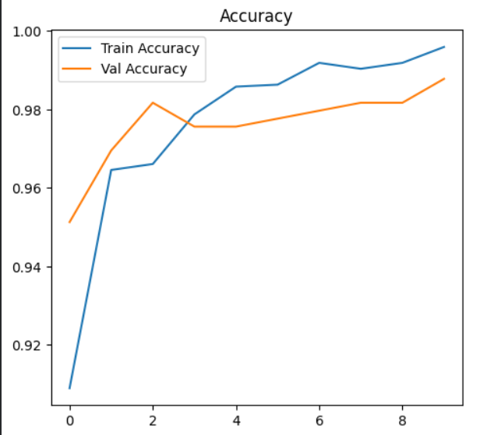
The accuracy graph shows that both training and validation accuracy gradually increased during each epoch. This indicates that the model learned the features of healthy and diseased capsicum leaves effectively and achieved high prediction accuracy.

Loss graph
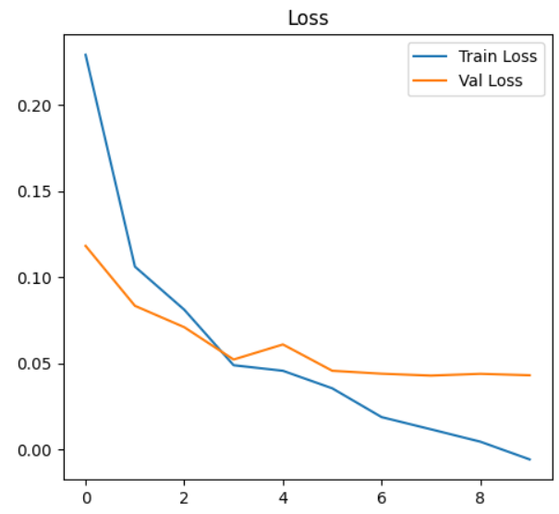
The loss graph shows that both training and validation loss decreased over time during training. Lower loss values indicate that the model reduced prediction errors and improved its overall performance.

WARNING:absl:You are saving your model as an HDF5 file via `model.save()` or `keras.saving.save_model(model)`. This file format is considered legacy. We recommend using instead the native Keras format, e.g. `model.save('my_model.keras')` or `keras.saving.save_model(model, 'my_model.keras')`.
This warning message indicates that the model was successfully saved using the .h5 (HDF5) file format, but TensorFlow considers this format outdated. It recommends using the newer .keras format because it provides better compatibility and improved support for future TensorFlow versions.
The warning does not affect the project or model performance. The model is still saved correctly and can be used for prediction and loading without any issues.

WARNING:absl:Compiled the loaded model, but the compiled metrics have yet to be built. `model.compile_metrics` will be empty until you train or evaluate the model.
This warning appears when a previously saved model is loaded into TensorFlow/Keras. It indicates that the model structure and weights were loaded successfully, but the evaluation metrics (such as accuracy) will only become active after the model is trained or evaluated again.
The warning does not indicate an error and does not affect prediction functionality. The loaded model can still be used normally for image classification and disease prediction.

1/1 ━━━━━━━━━━━━━━━━━━━━ 0s 135ms/step
🌿 Leaf Status: Healthy
✅ No disease detected.
💡 Recommendation:
- Maintain proper watering
- Use organic fertilizers like compost
- Ensure good sunlight exposure
- Regularly monitor plant leaves
Prediction: 0.9067516 | Result: Healthy

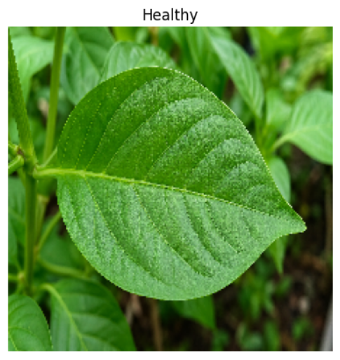
This output shows that the trained model successfully analyzed the uploaded capsicum leaf image and predicted it as a Healthy Leaf with a high confidence value of 0.9067. Since no disease was detected, the system also generated useful plant care recommendations such as proper watering, organic fertilizer usage, sunlight exposure, and regular monitoring of leaves.

1/1 ━━━━━━━━━━━━━━━━━━━━ 0s 86ms/step

🦠 Leaf Status: Bacterial Infection Detected
⚠️ Harmful: YES (can spread to other plants)

💊 Suggested Treatments:
- Use Copper-based fungicide (e.g., Copper Oxychloride)
- Apply Streptomycin spray (as per agricultural guidelines)
- Neem oil spray (organic option)

🌱 Fertilizer Suggestions:
- Avoid excess nitrogen fertilizers
- Use balanced NPK fertilizer (10-10-10)
- Add potassium-rich fertilizer to strengthen immunity

🛡️ Precautions:
- Remove infected leaves immediately
- Avoid overhead watering
- Keep proper spacing between plants
- Disinfect gardening tools
- Do not touch healthy plants after infected ones

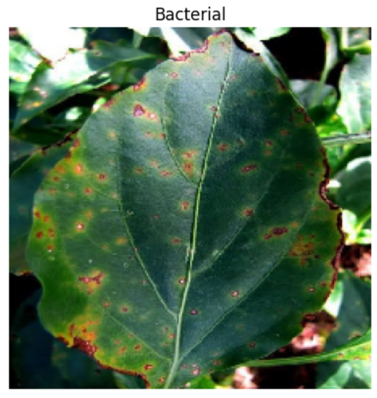
Prediction: 0.013383363 | Result: Bacterial
This output shows that the trained AI model successfully detected a Bacterial Infection in the capsicum leaf image with a low prediction value of 0.0133. After identifying the disease, the system automatically generated treatment suggestions, fertilizer recommendations, and preventive precautions to help control the infection and protect healthy plants from disease spread.

7.CONCLUSION
The AI-based Capsicum Plant Disease Detection System was successfully designed and implemented using Deep Learning and Image Processing techniques. The main objective of this project was to develop an intelligent system capable of identifying diseases in capsicum plant leaves accurately and efficiently. The project used the MobileNetV2 deep learning model along with TensorFlow and Keras libraries for image classification.
The system was trained using capsicum leaf images belonging to different categories such as healthy leaves and bacterial spot infected leaves. During training, the model learned important features and patterns from the images, which helped it classify the leaf conditions with high accuracy. The obtained training and validation results showed excellent performance with low loss values and high prediction accuracy.
The project includes several important stages such as dataset extraction, preprocessing, dataset organization, model training, evaluation, prediction, and visualization. The trained model successfully predicts whether a leaf is healthy or diseased by analyzing the uploaded image. Along with disease detection, the system also provides useful recommendations such as treatment methods, fertilizer suggestions, and preventive precautions to help users protect plant health and improve crop productivity.
Visualization graphs such as accuracy and loss plots were generated to monitor the learning performance of the model. These graphs helped in understanding the improvement of the model during training and confirmed the effectiveness of the deep learning approach used in the project.
One of the major advantages of this system is that it reduces the need for manual disease inspection and helps in early disease detection. Early identification of plant diseases can prevent the spread of infections, reduce crop damage, and support better agricultural management. The recommendation feature further increases the practical usefulness of the system by guiding farmers and users with proper disease control measures.
Overall, this project demonstrates how Artificial Intelligence can be effectively applied in the agriculture field to build smart farming solutions. The developed system is accurate, efficient, user-friendly, and capable of supporting modern agricultural practices. In the future, the project can be enhanced by adding detection for multiple plant diseases, integrating real-time camera support, developing a mobile application, and implementing cloud-based smart agriculture solutions for wider accessibility and real-world deployment.

8.FUTURE ENHANCEMENTS

The AI-based Capsicum Plant Disease Detection System can be further improved and enhanced in several ways to increase its accuracy, usability, and real-world applications. Although the current system successfully detects bacterial diseases in capsicum leaves, future developments can make the project more advanced and efficient for smart agriculture.
One of the major future enhancements is the addition of multiple disease detection. The current model mainly focuses on healthy and bacterial infected leaves, but in the future, the system can be trained to identify various plant diseases such as fungal infections, viral diseases, and nutrient deficiencies. This will make the system more useful for farmers and agricultural experts.
Another improvement is the development of a real-time mobile application. Integrating the trained model into an Android or web application would allow users to capture leaf images directly using a mobile camera and receive instant disease predictions and recommendations. This can improve accessibility and ease of use in agricultural fields.
The project can also be enhanced by implementing real-time camera detection using live video streams. This would allow continuous monitoring of crops and early disease detection without manually uploading images.
In future versions, the system can be connected with IoT-based smart farming devices such as temperature, humidity, and soil moisture sensors. Combining environmental data with disease detection can help in providing more accurate recommendations and improving crop management.
Another possible enhancement is the use of cloud computing and database integration. Storing prediction history, disease reports, and plant health records in a cloud database can help users track crop conditions over time and access reports from anywhere.
The accuracy of the model can also be improved by:
- Using larger datasets
- Applying advanced data augmentation techniques
- Training with more powerful deep learning models
- Fine-tuning hyperparameters
Additional features such as multilingual support, voice assistance, and automatic pesticide recommendation systems can further improve user interaction and practical implementation.
Overall, future enhancements can transform this project into a complete smart agriculture solution capable of supporting farmers with fast, accurate, and intelligent plant disease management systems.

- BIBLIOGRAPHY
- Hands-On Machine Learning with Scikit-Learn, Keras, and TensorFlow – O’Reilly Media
- Python Machine Learning – Packt Publishing
- Deep Learning with Python – Manning Publications
- The Hundred-Page Machine Learning Book
- Introduction to Machine Learning with Python – O’Reilly Media
- Artificial Intelligence: A Modern Approach – Prentice Hall
- Deep Learning – MIT Press
Research & Learning Resources
- TensorFlow Documentation
- Keras Documentation
- MobileNetV2 Architecture Tutorials
- Deep Learning and Image Processing Study Materials
Websites
- Jupyter Notebook
- Visual Studio Code
- Google Colab
- TensorFlow Official Website

